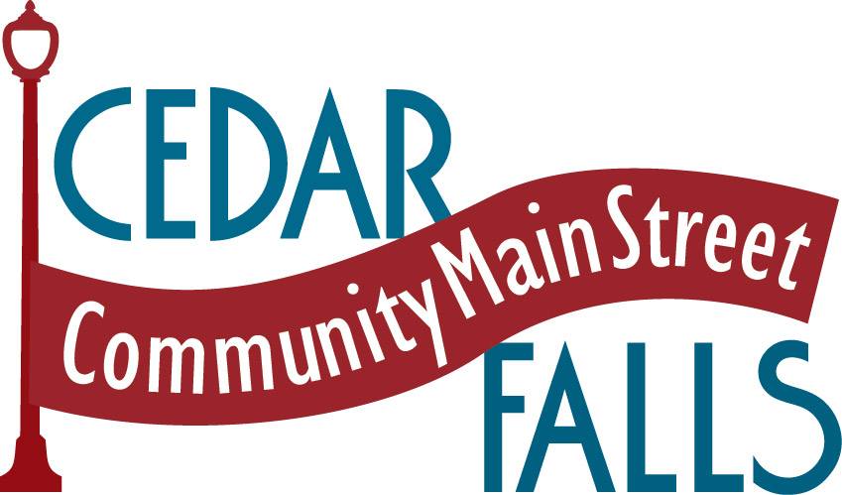

FOR IMMEDIATE RELEASE: November 11, 2016

Contact Information:

Media Contact:
Carol Lilly, CMS Executive Director
Community Main Street
206 Main Street, Suite B
Cedar Falls, IA 50613
319-429-0468 (cell)
319-277-0213 (office)
cmsdirector@cfu.net

Five Local Retailers attend Main Street Iowa Training
Nationally acclaimed retail expert Margie Johnson visits Iowa

Recently, representatives from Community Main Street’s Retail Promotions Committee attended a two-day retail training session in Mount Pleasant hosted by Main Street Iowa and conducted by Margie Johnson, a nationally acclaimed speaker, trainer, author and consultant. Johnson, founder of Shop Talk, helps companies achieve their best performance and gain a competitive edge.

Topics covered during the training were: 1) key trends affecting retail and hospitality businesses, 2) key factors shaping today’s retail landscape, 3) trends in consumer buying habits, 4) the importance of “experience retailing” and consumer engagement, 5) impact of retail sales from the internet, and 6) understanding generational considerations to be addressed in today’s business climate.

Attendees from Cedar Falls, shown left to right on the attached photo, included: Rhonda Hinton (Pink Peony), Barb Woods (World’s Window), Julie Shimek (Vintage Iron), Carlene Danielsen (Basket of Daisies) Carol Lilly (Community Main Street) and Natalie Meester (Little Praire Girl).

Downtown Cedar Falls provides an award winning retail shopping experience and was recently recognized as Iowa’s Outstanding Retail Experience by Travel Iowa and the Travel Federation of Iowa.

Community Main Street is a volunteer driven, non-profit organization established to foster economic vitality, and to preserve and promote the historic image and character of the downtown, while improving the quality of life in Cedar Falls.

###

